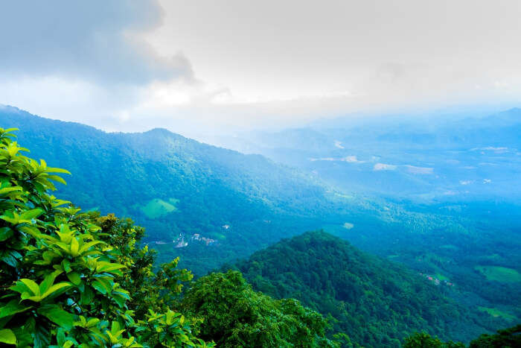

Explore Wayanad!

Vaishnavi V | Applied Data Science Capstone Project | 14-May-21

# Introduction

Explore Wayanad! Is my capstone project, which is a part of the course Applied Data Science Project.

This project is targeted to be helpful for those who wish to explore Wayanad.

Wayanad is a district in north-east Kerala. Wayanad is a place that is suitable for visiting during any time of the year, and is a famous tourist spot among adventurers. It is filled with varied ranges of attractions, including waterfalls, trekking, historical, religious and is one of the most preferred destinations for a weekend gateway.

Wayanad is a hill station. Every tourist spot in this district will fill the traveler with peace and tranquility.

However, since it is a hilly region, different tourist spots are spread across the hilly regions, and not every spot has restaurant facilities near it. Food, is an important part of any trip. And the availability of healthy food is an important consideration while planning a trip.

The intent of this project is to list out the famous spots in Wayanad to visit, and for each of these attractions, we will be listing the nearest restaurant to the spot and its distance from the spot. This will help the travelers plan their trip more efficiently.

# Data

The data used in this project have been collected from two sources.

* OpenStreet map API
* Foursquare API

**OpenStreep Map API** is used for providing tourist destinations in Wayanad. The data provided by this API mainly includes –

* Name
* Rating
* Distance from the given center location (in this case Kalpetta)
* Type of place
* Geographical coordinates for each tourist destination (Latitude, Longitude)
* Address, etc.

The main arguments to OpenStreet map API are –

* API Key
* Radius
* Latitude
* Longitude
* Kinds of places (We have used interesting places, sports and amusements here)

Example of the data collected through OpenStreet map API –

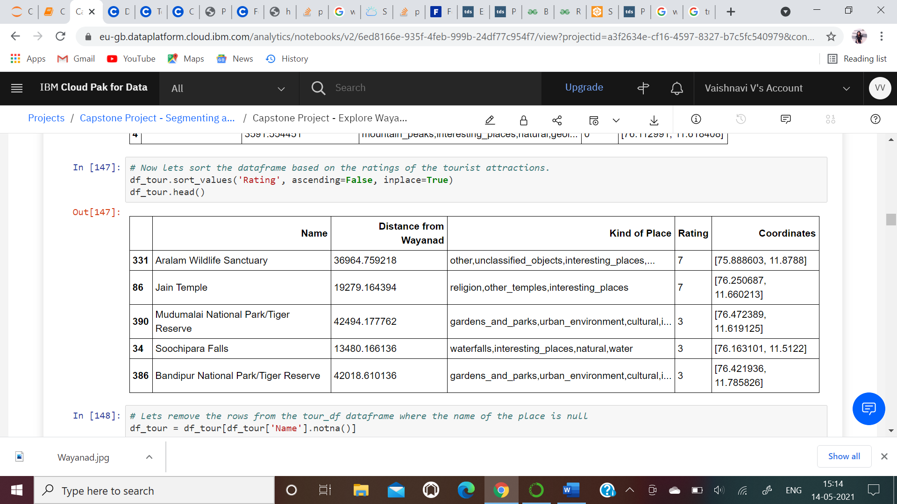

This is a raw data that is retrieved through this API. This data will be processed and cleaned further.

**Foursquare API** is used for providing information about nearby restaurants to each of the tourist spot identified by OpenStreet map API. The nearest restaurant is chosen and displayed.

The main arguments to Foursquare API are –

* Client ID
* Client Secret
* Limit
* Version
* Latitude
* Longitude
* Search query (Restaurant, lunch specified here)
* Radius from the given latitude, longitude

The latitude and longitude argument that will be used in Foursquare API will be derived from what is returned by OpenStreet map API. The Foursquare API will be called recursively for each tourist location returned by OpenStreet map API.

# Methodology

As the first step, we retrieve the data from OpenStreet map API and this becomes our base data.

We extract information about all the tourist attractions in Wayanad within a distance of 50 Km from the center of Wayanad.

The data that we extract from the results of this API include tourist spot name, its distance from our center location, its ratings based on user experience and it’s geographical coordinates (Latitude and Longitude).

The distance that is retuned by this API is originally in meters unit. We convert it into Km unit and round it off. Latitude and Longitude are retuned as a single list for each tourist spot, which are then segregated into two separate columns.

As the next step, we use the latitude and longitude that we have derived for each spot in the previous step.

We supply the latitude and longitude for each tourist spot in Wayanad to the Foursquare API, and call the Foursquare API recursively for each tourist spot.

The data returned by the Foursquare API that is significant to this project include a list of restaurants within a distance of 20 Km to the tourist spot, and the distance of the restaurant from the spot.

We use 20 kilometers as the radius for searching here because Wayanad is a hill station, and not every tourist spot here is easily accessible. And many locations here may not have a restaurant in their immediate surroundings.

Next the data returned by the Foursquare API are combined with what have derived from the OpenStreet map API.

This gives us a conclusive dataframe with information about 397 locations in Wayanad, and restaurant information for each of these locations.

Next, we also perform an analysis on the Restaurants information that we got. On plotting a bar graph for the Restaurants, it can be inferred that in most of the scenarios, one restaurant happens to be close to multiple tourist locations. This information can be very handy while planning a trip. All such places around a particular eatery can be combined for a day to visit.

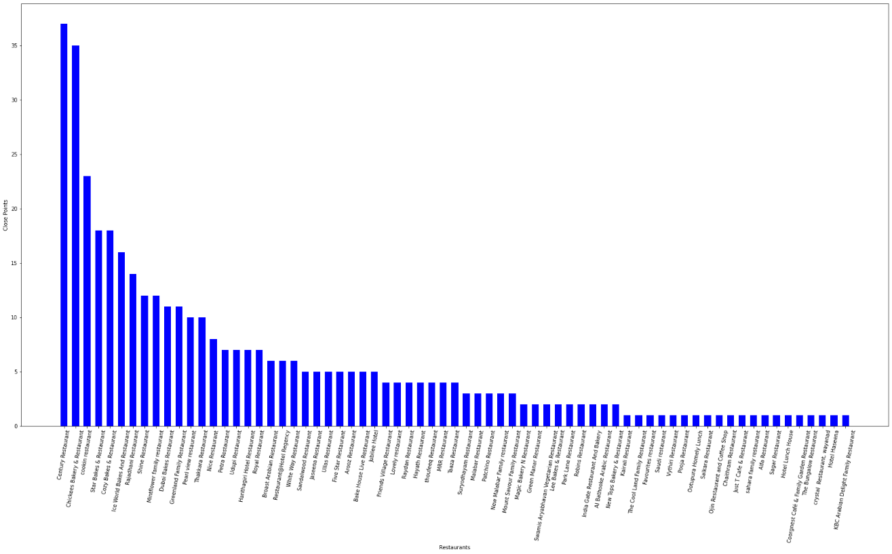

As seen in the above bar graph, the restaurant **Century Restaurant** is close to 37 locations in Wayanad.

# Results

Data from both the APIs – OpenStreet map and Foursquare are retrieved.

OpenStreet map API initially returned 500 entries of locations. But they were filtered again based on rating criteria. That is, locations with a rating of 0 were ignored, and this filtering resulted in a total of 397 entries to visit.

The maximum rating for any location in our data is 7. For each of these 397 locations, restaurant locations around this location were queried, and we have the closest restaurant information captured for each of these 397 tourist spots. Any person planning to visit any of these tourist spots can simply lookup their place of interest in this data and identify the restaurant near that location.

Please find a portion of our finable table with all the data combined –

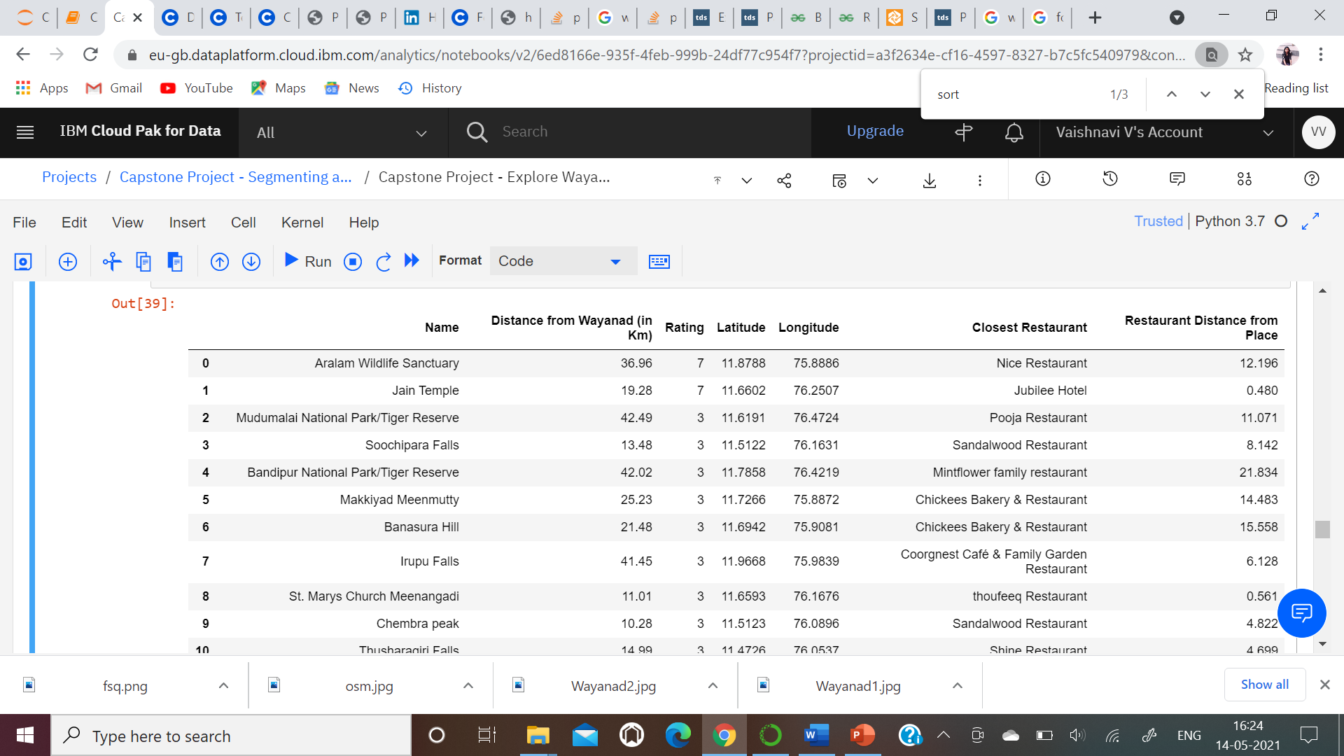

Also, **k-means clustering algorithm** has been used to cluster the geospatial information and plot them on the map. There are 6 clusters, which are color coded, and hovering on each spot gives the place name and their respective cluster number.

From this map, the locations in individual clusters can also be used to plan the travel.

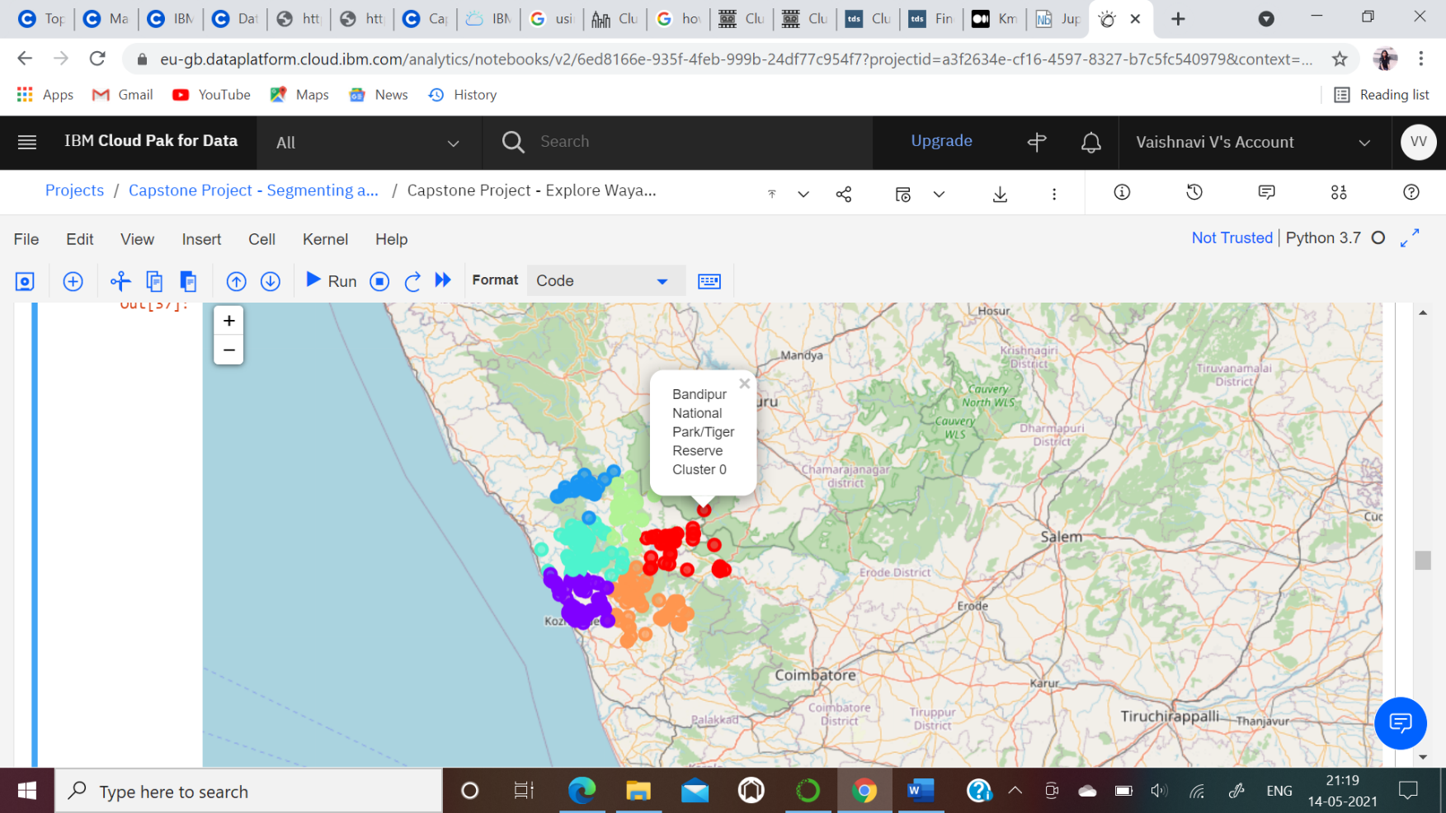

# Discussion

From the data retrieved from the APIs, it is confirmed that a nature lover is going to have a memorable stay in Wayanad.

The two highest rated places to visit as per the API results happen to be Aralam Wildlife Sanctuary and Jain Temple. These places are a little distanced from the center of Wayanad, but are definitely worth a visit.

The other wonderful places to visit include Soochipara falls, Bandipur Tiger Reserve, Meenmutty falls, etc. which have got a rating 3 as per the API results.

Around 37 locations happen to be located around Cookin Restaurant, which can be easily clubbed for a visit back to back!

# Conclusion

The purpose of this project was to provide useful information and guide those who want to visit Wayanad.

The venues to visit have been identified using OpenStreet map API, and the restaurant information around these venues have been identified using Foursquare API.

The locations identified by OpenStreet map API are clustered and plotted on map.

With this data, one will always have an idea about where to find good food and can plan their trip accordingly!